

SPICES

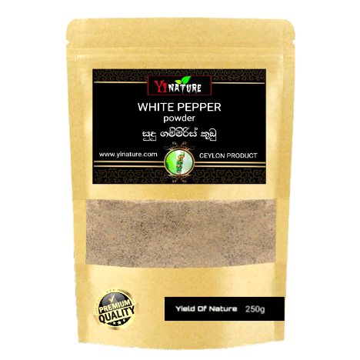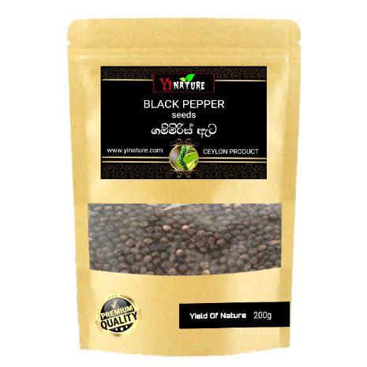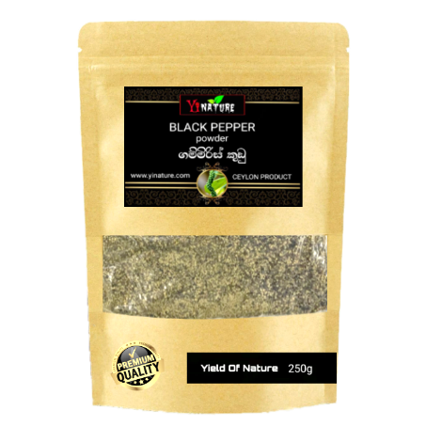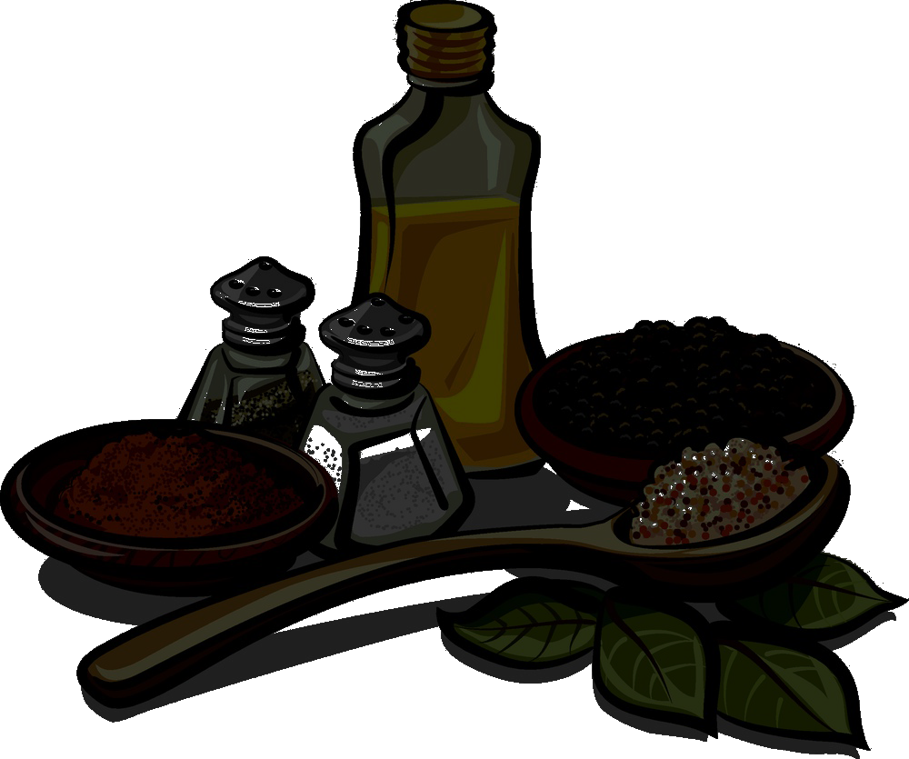**CBLACK PEPPER POWDER**

Size : 200g

Who.Price : Rs.390.00

Sale Price : Rs.465.00

Size : 50g | 250g |750g

Who.price(Rs) : 175 | 490 | 1105

S.price(Rs) : 210 | 595 | 1120

::

Size : 50g | 250g

Who.Price (Rs): 205 | 605

Sale Price (Rs) : 245 |725

**WHITE PEPPER POWDER**

**BLACK PEPPER POWDER**

**CK PEPPER POWDER**

**BLACK PEPPER CORN pPPPKCDPOWDER**

**BLACK PEPPER POWDER**

**CK PEPPER POWDER**

**BLACK PEPPER POWDER**

**BLACK PEPPER POWDER**

**CK PEPPER POWDER**



SPICES

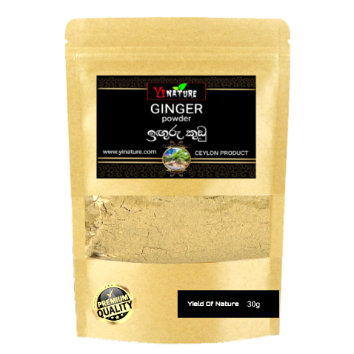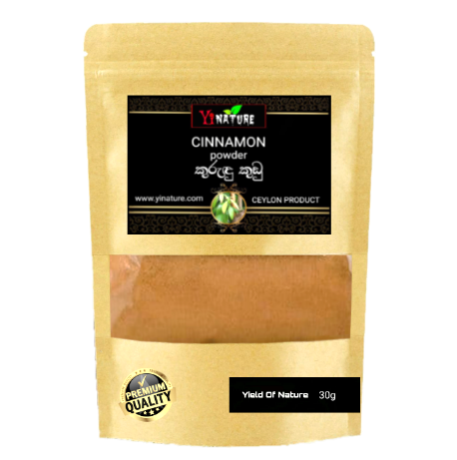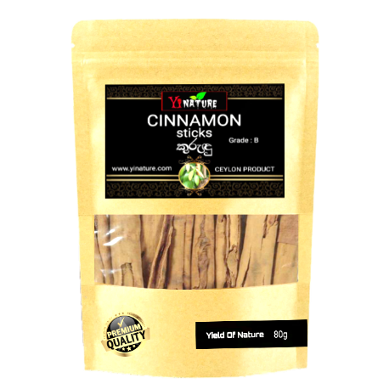

**GINGER POWDER**

**BLACK PEPPER POWDER**

**CK PEPPER POWDER**

Size : 30g

Who.price : Rs:235.00

S.price : Rs: 285.00

::

Size : 30g

Who.price : Rs: 150.00

S.price : Rs: 190.00

::

**CINNAMON STICKS**

**BLACK PEPPER POWDER**

**CK PEPPER POWDER**

**CINNAMON POWDER**

**BLACK PEPPER POWDER**

**CK PEPPER POWDER**

Size : 80g

Who.price : Rs:420.00

S.price : Rs:505.00

::